- Appointment:
To make an appointment of the patient either walk in Patient or Patient who can make appointment via online portal. We can make an appointment with different modes like personally visit at hospital, online or telephonically.

Appointment Duty Schedule: For the Appointment we have make the availability schedule with days with different slots for doctors.

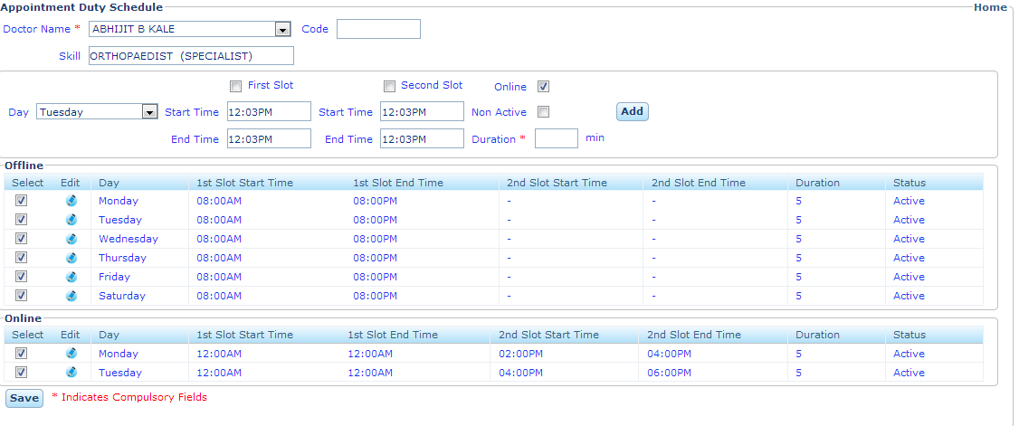
Days: We can schedule the doctor appointment day wise.
First Slot: We can schedule the doctors in different time slots.
Second Slot: We can schedule the doctors in different time slots.
Duration: The total time takes by the doctor to consult the patient.
Online: To schedule the online appointment check the online button.

Doctors Appointment Schedule: When we select the Doctor, Appointment Schedule of the Date is List out.

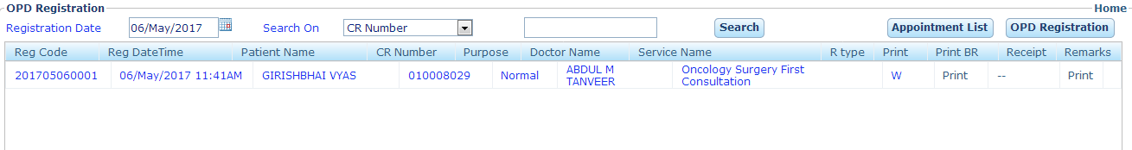
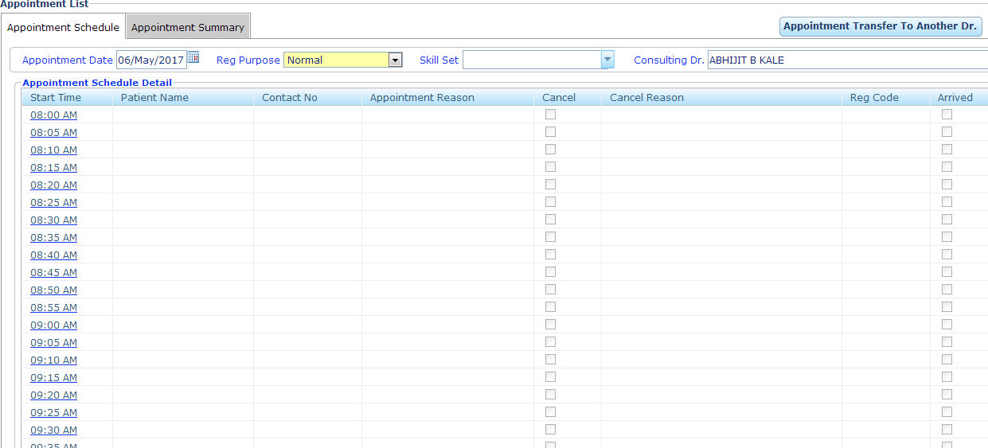

Make Appointment:
To make the appointment select the date & time of the appointment, Appointment type and Booking Mode, single/ Multiple Appointment, Service Name & fill the Reason of Appointment.
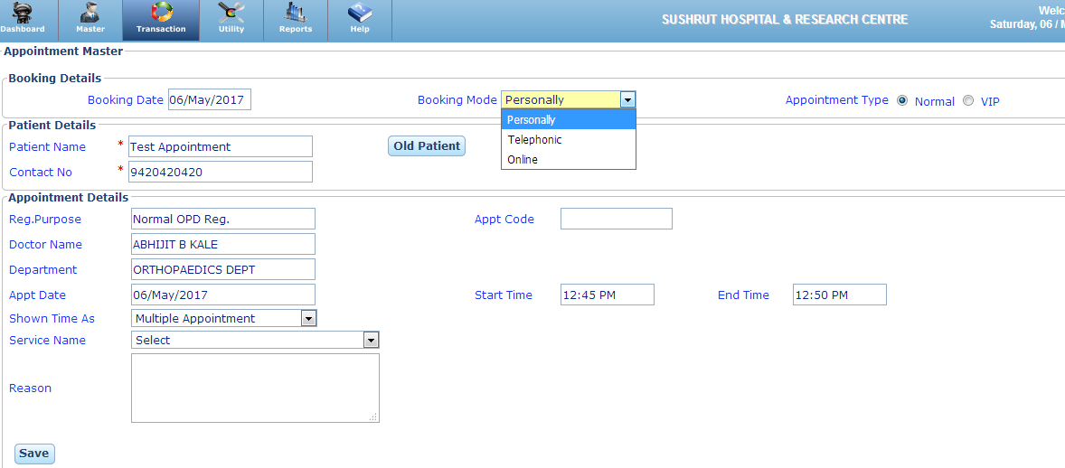
Booking Date: Select the Date of Appointment.
Single Appointment: We can make a single appointment in a particular time slot.
Multiple Appointment: We can make a multiple appointment in a particular time slot.
Booking Mode: Select the Mode of Booking like Personally, Telephonic or Online.
Service: Select the consulting service first or follow up.
Reason/ Remark: Purpose for the Appointment.

- Appointment List: It shows the list appointed Patients as follows:
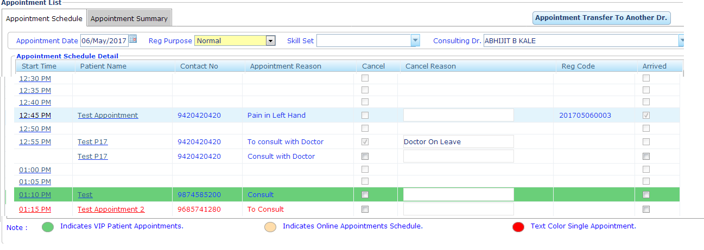
Appointment Reason: Reason for Appointment
Cancel Reason: If an appointment is cancel the Reason for appointment cancel is show.
Arrived: if arrived flag is check means appointment is confirmed.
Re. Code: OPD Registration is appears when an appointment is confirmed.
Appointment Cancel: To cancel is appointment we have to click on cancel button and enter the reason for cancellation.
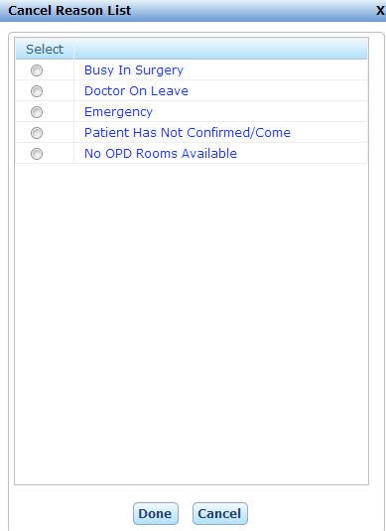
OPD Appointment Transfer to another Doctor:
When a doctor is not available for whatever reason, we can shift all the appointments to the doctor of same specialty.
